Automating Workflows for Moiré Materials:

Constructing Phase Diagrams from

Transport Data for Moiré WSe2

Eric Wang, Xiao Wang, Yiyu Xia, Eun-Ah Kim
Department of Physics, Cornell University
August 21, 2026

Background & Goal

Phase diagrams provide valuable information for further understanding moiré materials and various phenomena such as superconductivity. Additionally, a well-constructed phase diagram can inform experimentalists which regions of phase space are most interesting to explore next. However, the typical workflow (outlined here, for our system, twisted WSe₂ bilayer) to construct phase diagrams is laborious and time-consuming, taking an expert around 2-3 days to complete just one phase diagram. Additionally, since the transport data is extremely noisy, the resulting phase diagram is prone to human error and can be difficult to debug.. All in all, this makes constructing phase diagrams a bottleneck in exploring the phase space of moiré materials.

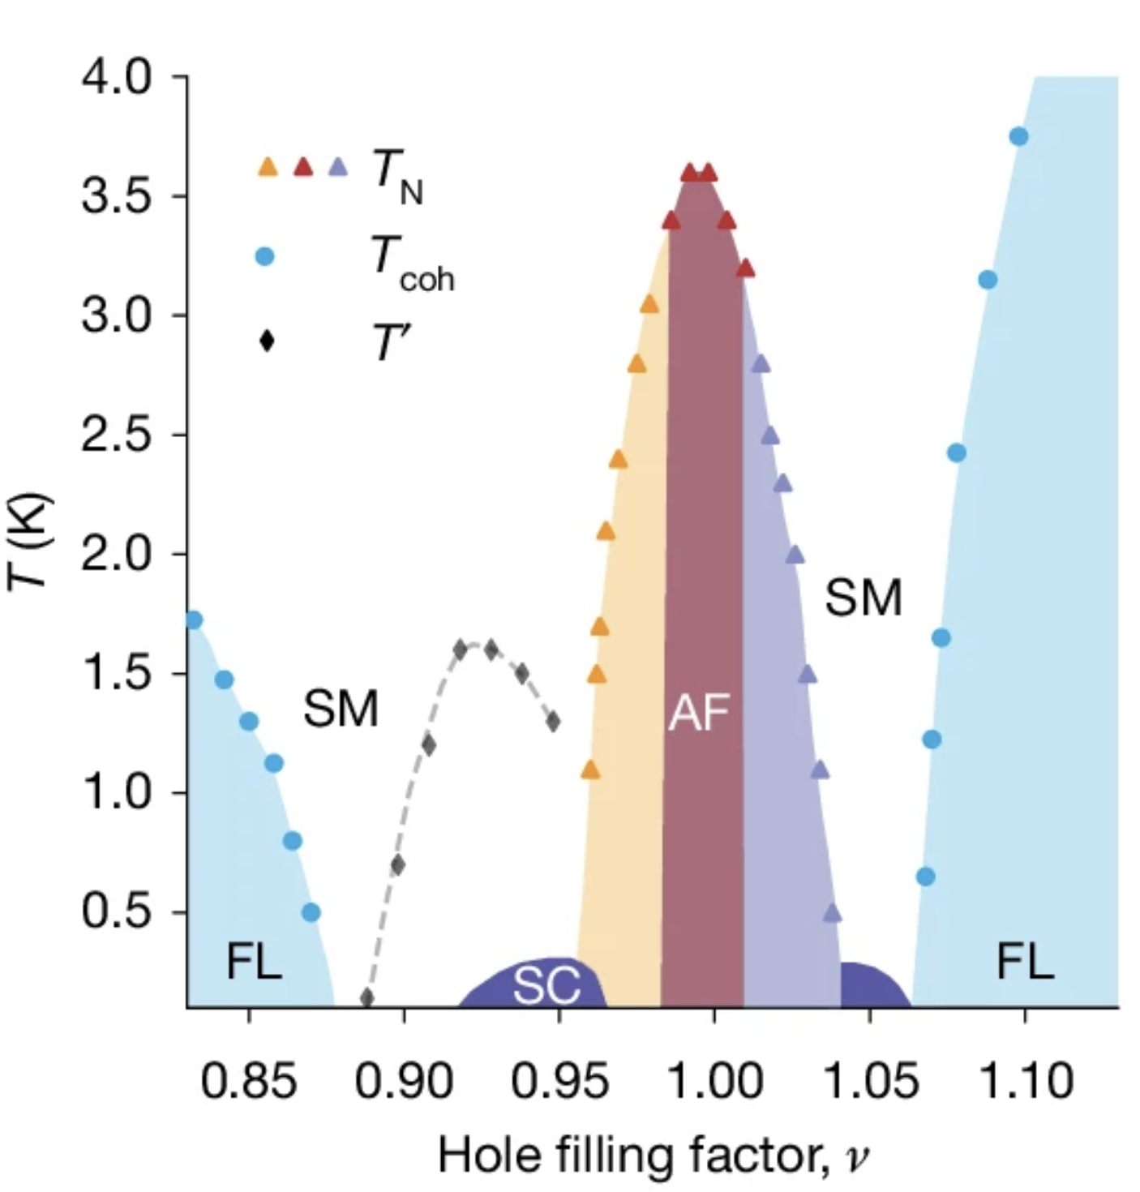
Figure 1. Phase Diagram for E = -103 mV/nm dataset
Reproduced from Xia et al.

Accordingly, the goal of this project is to automate a data analysis workflow for moiré materials in which experimental physicists analyze transport data of moiré materials in order to construct phase diagrams. Automating the construction of phase diagrams using a deterministic pipeline provides several advantages compared to manually constructing them. First, it saves time - the pipeline takes at most minutes to construct a phase diagram whereas it takes several days for an expert human to do so. Additionally, a deterministic pipeline introduces reproducibility and makes it easy for peers to review the validity of published phase diagrams.

Challenges

Constructing phase diagrams from transport data contains many uncertainties that even an expert will not know the answer to.

The nature of the collected transport data presented many challenges to constructing phase diagrams. First, the transport data is extremely noisy, which makes it at times difficult for even human experts to distinguish real features from noise.

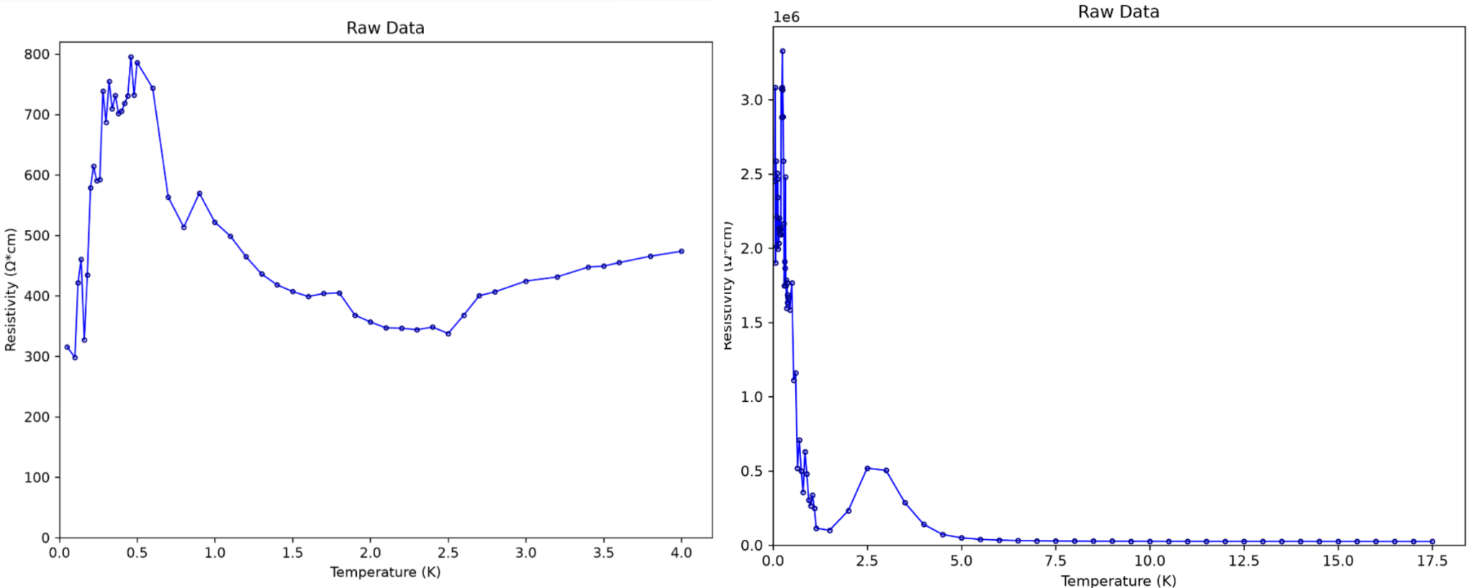

Figure 2. Resistivity linecuts demonstrating uneven T spacing and ρ dependent noise

For example, the figures above illustrate how the noise in the data makes it difficult to distinguish real local minima from just noise, particularly in the low temperature region of the right graph. To resolve this challenge, I developed a custom smoothing algorithm that smoothes out noise from the data while preserving real features, such as local minimums and maximums, which I will explain in the methodology section.

Additionally, the data presented ambiguous transition temperatures, which made it difficult, especially by hand, to pinpoint the exact temperature at which a phase transitions from one to another. For example, in the graph on the left in Figure 3, the resistivity linecut subtly transitions from T² dependency to linear T dependency, indicating a phase transition from Fermi liquid to strange metal. However, the exact temperature at which the dependency transitions is ambiguous, and the noise makes that ambiguity even worse.

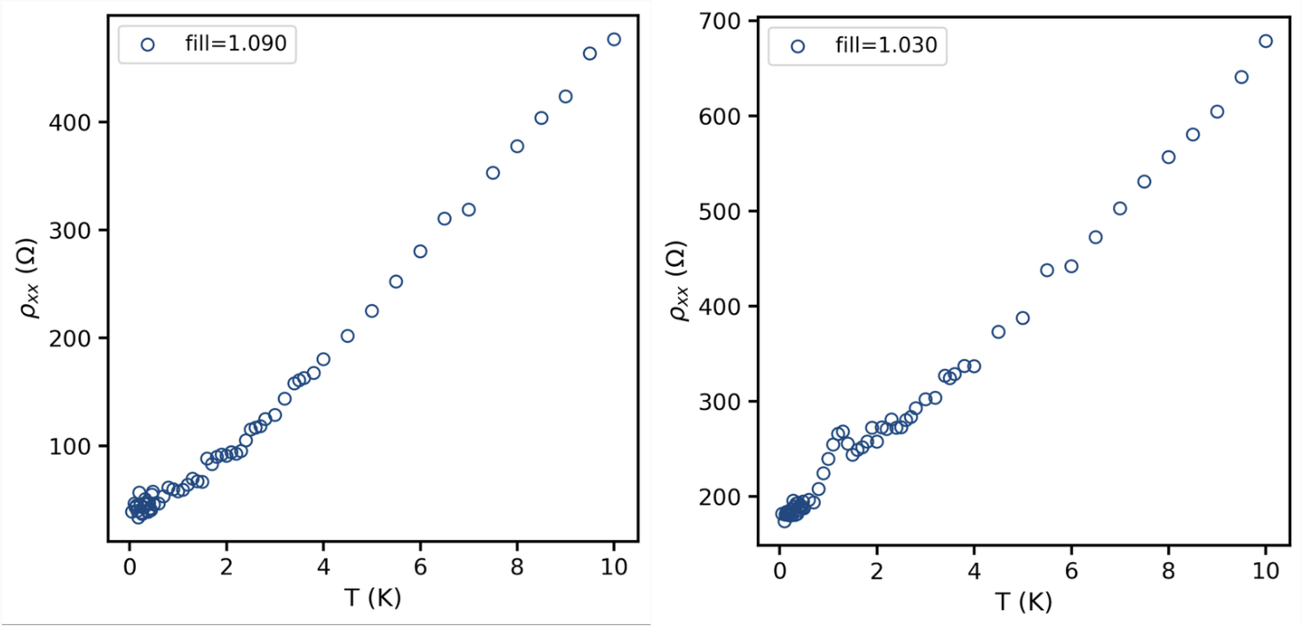

Figure 3. Resistivity linecuts demonstrating ambiguous transition temperatures

To resolve this ambiguity, I had to use each linecut’s neighboring linecuts and whether they agreed with their neighboring features, which I will also explain in the methodology section.

Methodology

The deterministic data pipeline so far constructs preliminary phase diagrams that reliably display the behaviors and features of the transport data: local minimums, local maximums, as well as regions of linear and quadratic dependencies. I made this design choice because of the nuanced nature of labeling phases from transport data. For example, while quadratic dependency of resistivity on temperature at low temperature regions may be strongly suggestive of the Fermi liquid phase, the same quadratic dependency at high temperatures may be less suggestive of the same phase. As such, the pipeline becomes more flexible and easier to debug if the process of phase labeling is separated into two parts: first, extracting features/behaviors, second, labeling the phase - either leaving the labeling to an expert human or an agent with external knowledge.

The general outline of the pipeline is illustrated in Figure 4 below. The pipeline first smoothes the data - removing noise while preserving potential features. Then, it selects plausible local minimum and maximums in the data, and refines it based on its agreement with neighboring linecuts. Following, in the remaining regions, the pipeline selects plausible T² regions and generates candidate T_{coh}, points whereby the measured resistivity deviates from the T² fit by more than 10%. Likewise, the same is done with a logarithmic fit for T’ candidate extraction. Finally a boundary is drawn to connect the candidate points. At this point in time, the T’ candidate extraction and drawing of the phase boundary have not been developed, but the other features work reliably well.

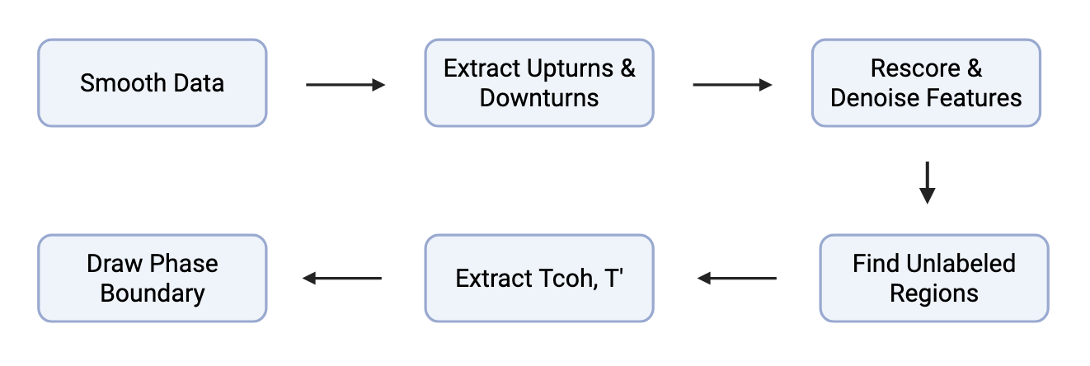
Figure 4. Flowchart of Data Pipeline

Now, I will explain the components of the pipeline in more detail.

Standard methods such as the Savitzky-Golay filter use a fixed window around each data point and fits a local polynomial inside each window to smooth data. However, since the data exhibits uneven T spacing as well as features and noise of various magnitudes, a Savitzky-Golay or moving average often fails to fully capture all of the features while smoothing out the noise.. To resolve this problem, I built on top of the standard Savitzky-Golay filter by creating an adaptive window selector. When features are small, the window selector outputs a small window for polynomial fitting, whereas when features are large, the window selector outputs a large window for polynomial fitting. As a result, the adaptive window enables the fitted polynomial to both capture small features while aggressively smoothing out noise.

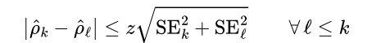

The window selector uses the following heuristic to select a window: a small window captures noise, while a large window removes features. Accordingly, the selector starts with a small window and fits local polynomials over successively larger windows. As long as the fits agree, increasing the window size removes more noise without significantly changing the underlying feature. However, once the window becomes large enough that it is washing out a real feature, the fit will start to disagree, and we select that window for smoothing. The selector uses a z-score metric, shown in the equation above, to evaluate whether two fits disagree or not, and thus the level of smoothing can be tuned using the z value.

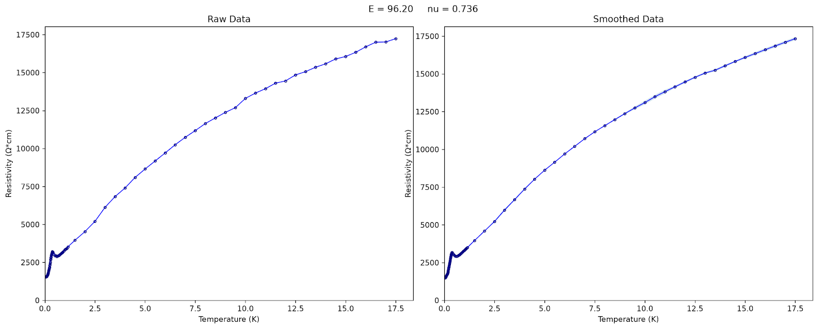

Figure 5. Resistivity linecut demonstrating the smoothing algorithm:
it leaves a small feature (minima) of ~ 0.5K in width intact after smoothing

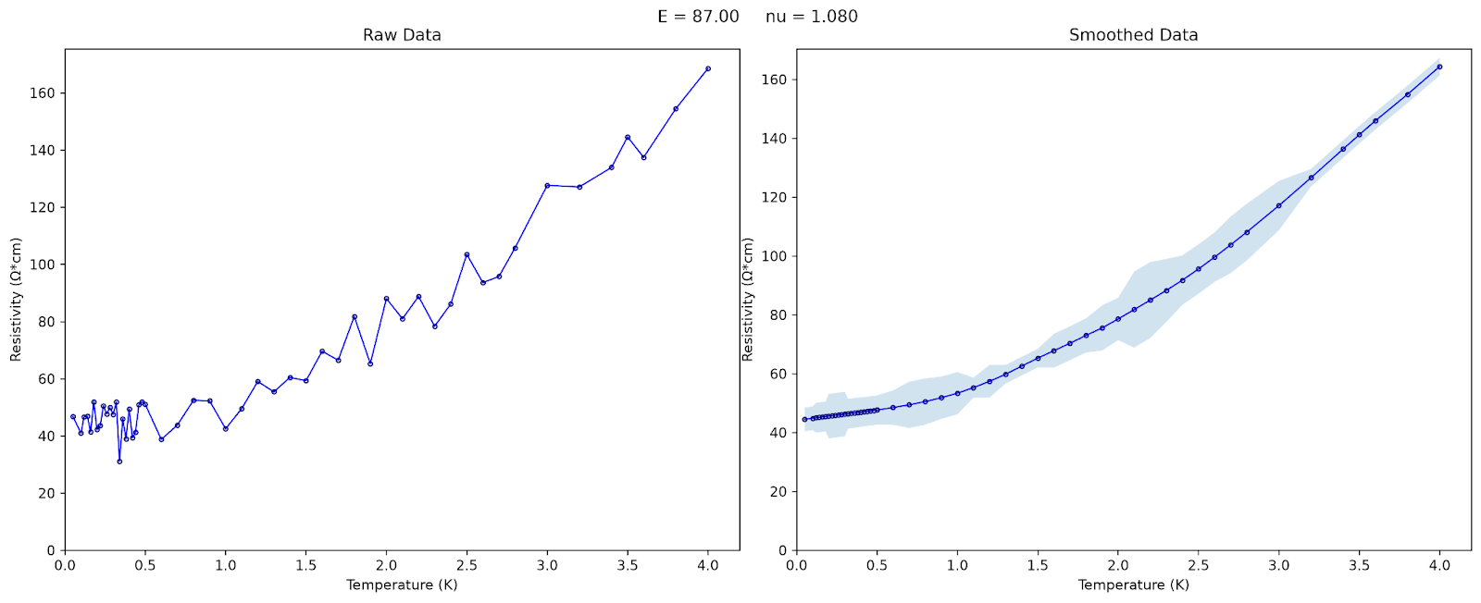
Figure 6. Linecuts demonstrating the smoothing function
aggressively smoothing local extremum due to noise

Error bars around the line is estimated noise calculated from the
difference between smoothed and raw data

Then, local minimums and maximums, which suggests an AFM transition, are selected and scored based on their relative size. Because the units of the resistivity can change from experiment to experiment, the pipeline should be made generalizable. As a result, I scored the local extrema based on the weighted geometric mean of the following metrics: the prominence of the peak compared to the surrounding noise, the number of points within the peak, as well as the temperature range of the peak.

The overall score is
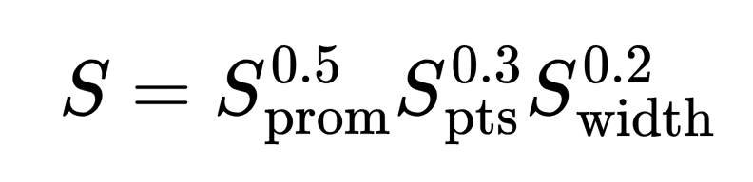

Where each metric is mapped to [0, 1] with a hill sigmoid
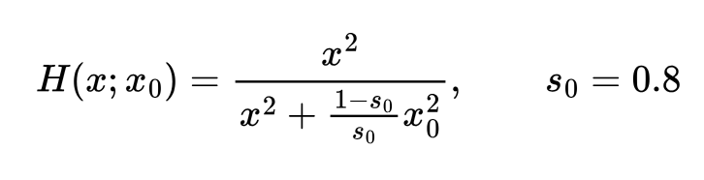
Where
This scoring metric reduces the risk that a large peak or dip receives a high score, as the prominence of the peak will be normalized by its surrounding noise.

After scoring, the features are refined and denoised according to their agreement with their neighboring features. This stems from the physical nature of phase boundaries - they are smooth and continuous. The exact process is outlined in Figure 7. For each feature, a support score is calculated from whether there is a local extrema close to it. Then, each score of the feature is updated by interpolating it with the support score. After obtaining an updated score, a new support score can be calculated from the new score and the same process repeats iteratively. There is a periodic denoising step within the iterations to remove the noise, or else features with low confidence will remain in the candidate pool.

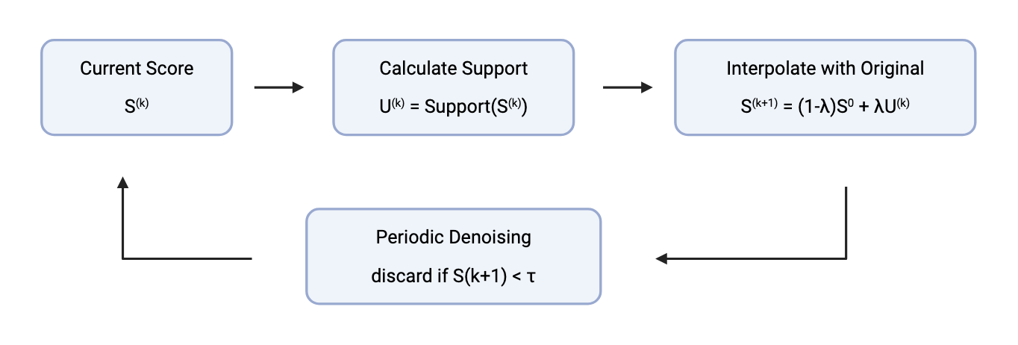
Figure 7. Flowchart showing iterative denoising and refinement of local extrema

The support score is calculated based on the following formula:

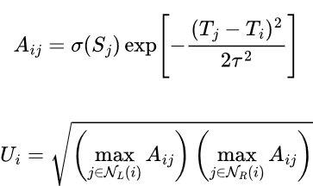

Calculating the support score as the geometric mean of the max agreement value A_{ij} of the left and right neighborhood of the feature ensures that the new score increases when it is supported on its left and right side, while simultaneously preventing a branch of low confidence features from being lifted up by a single high-confidence feature. Figure 8 below illustrates how the iterative refinement increases the scores of features where they are well supported by both sides, as well as how the periodic denoising removes isolated features that are likely noise.

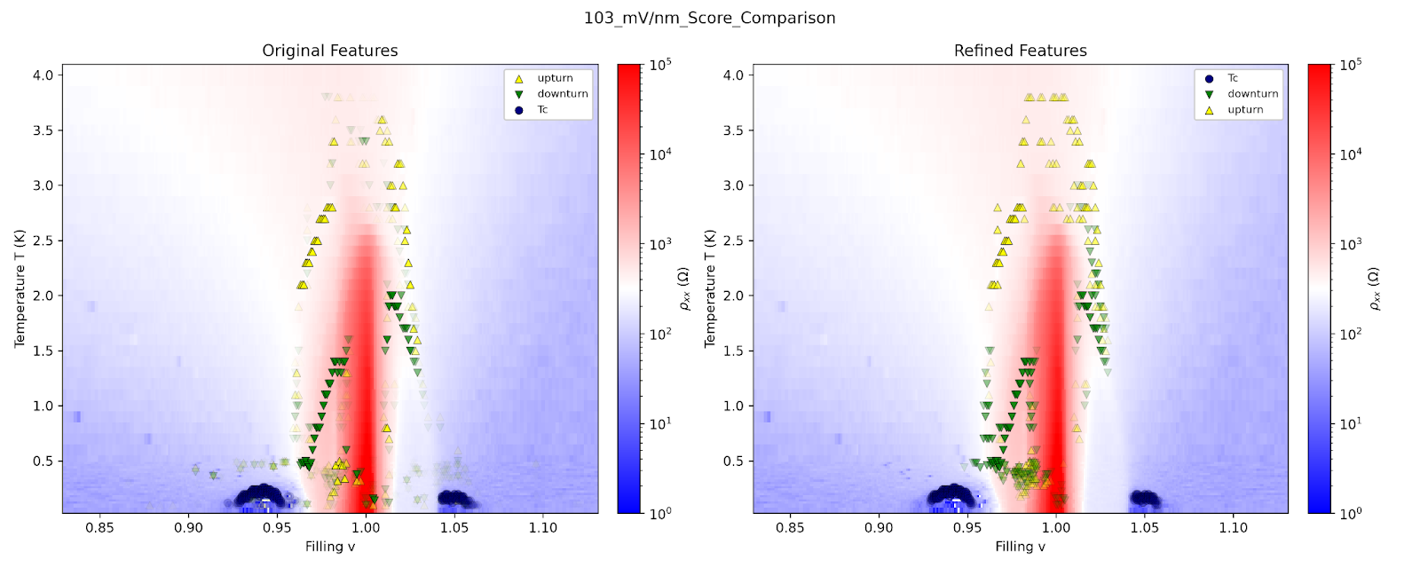
Figure 8. Comparisons of original features with refined features

Then, in order to extract the coherence temperature T_{coh}, the pipeline finds remaining unlabeled regions that are metallic (dρ/dT > 0), and fits a polynomial ρ ~ ρ₀ + AT² over the regions, keeping the fitted polynomials that had a goodness-of-fit p-value greater than 0.2.

For the regions remaining, the point at which the predicted value differs from the measured value by more than 10% is collected as part of plausible T_{coh} candidates. Figure 9-13 below illustrates the generated phase diagram with T_{coh} overlaid on top along with other features.
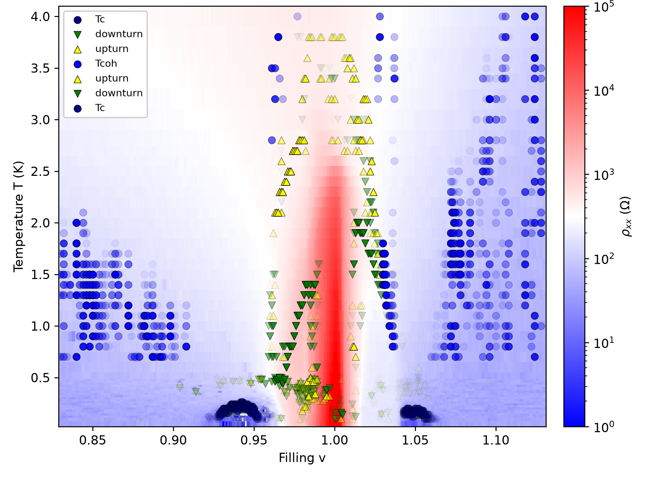
Figure 9. Side by side comparison of phase diagram generated for
E = -103 mV/nm dataset
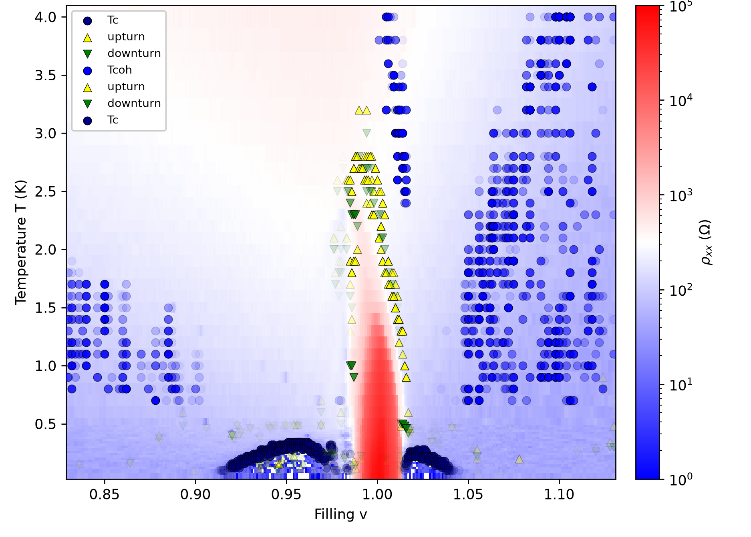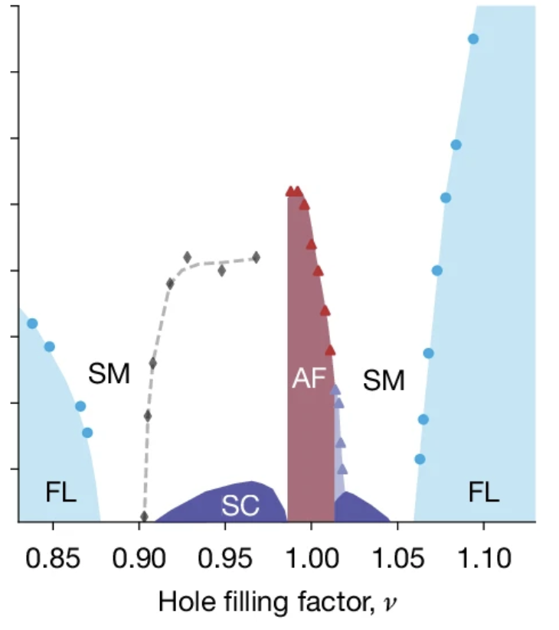

Figure 10. Side by side comparison of phase diagram generated for
E = -96 mV/nm dataset

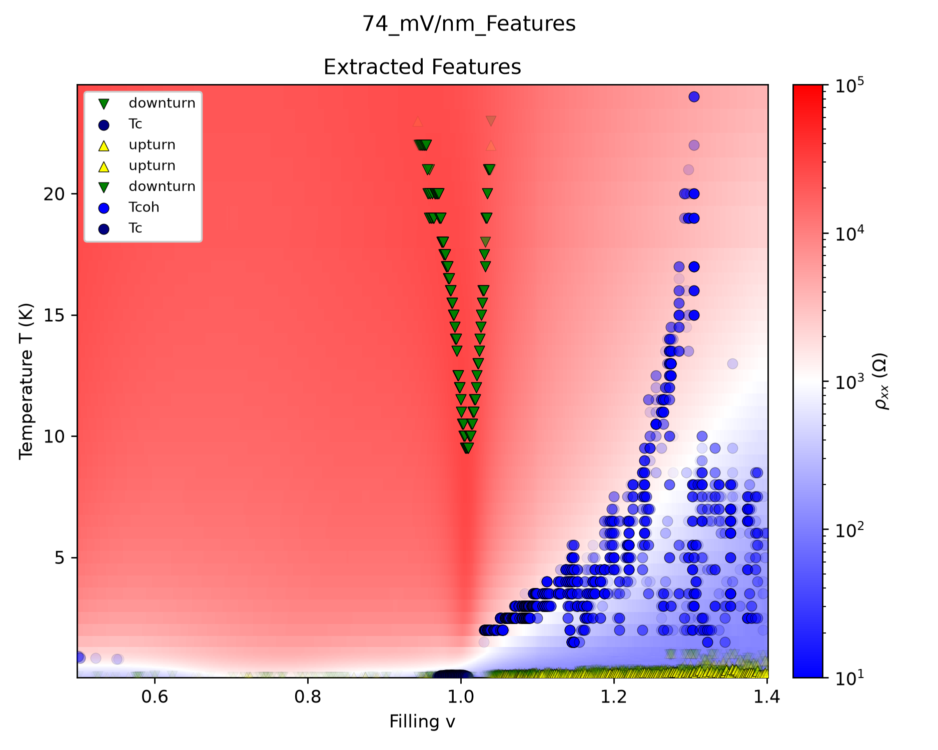

Figure 11. Generated phase diagram for E = -74 mV/nm dataset
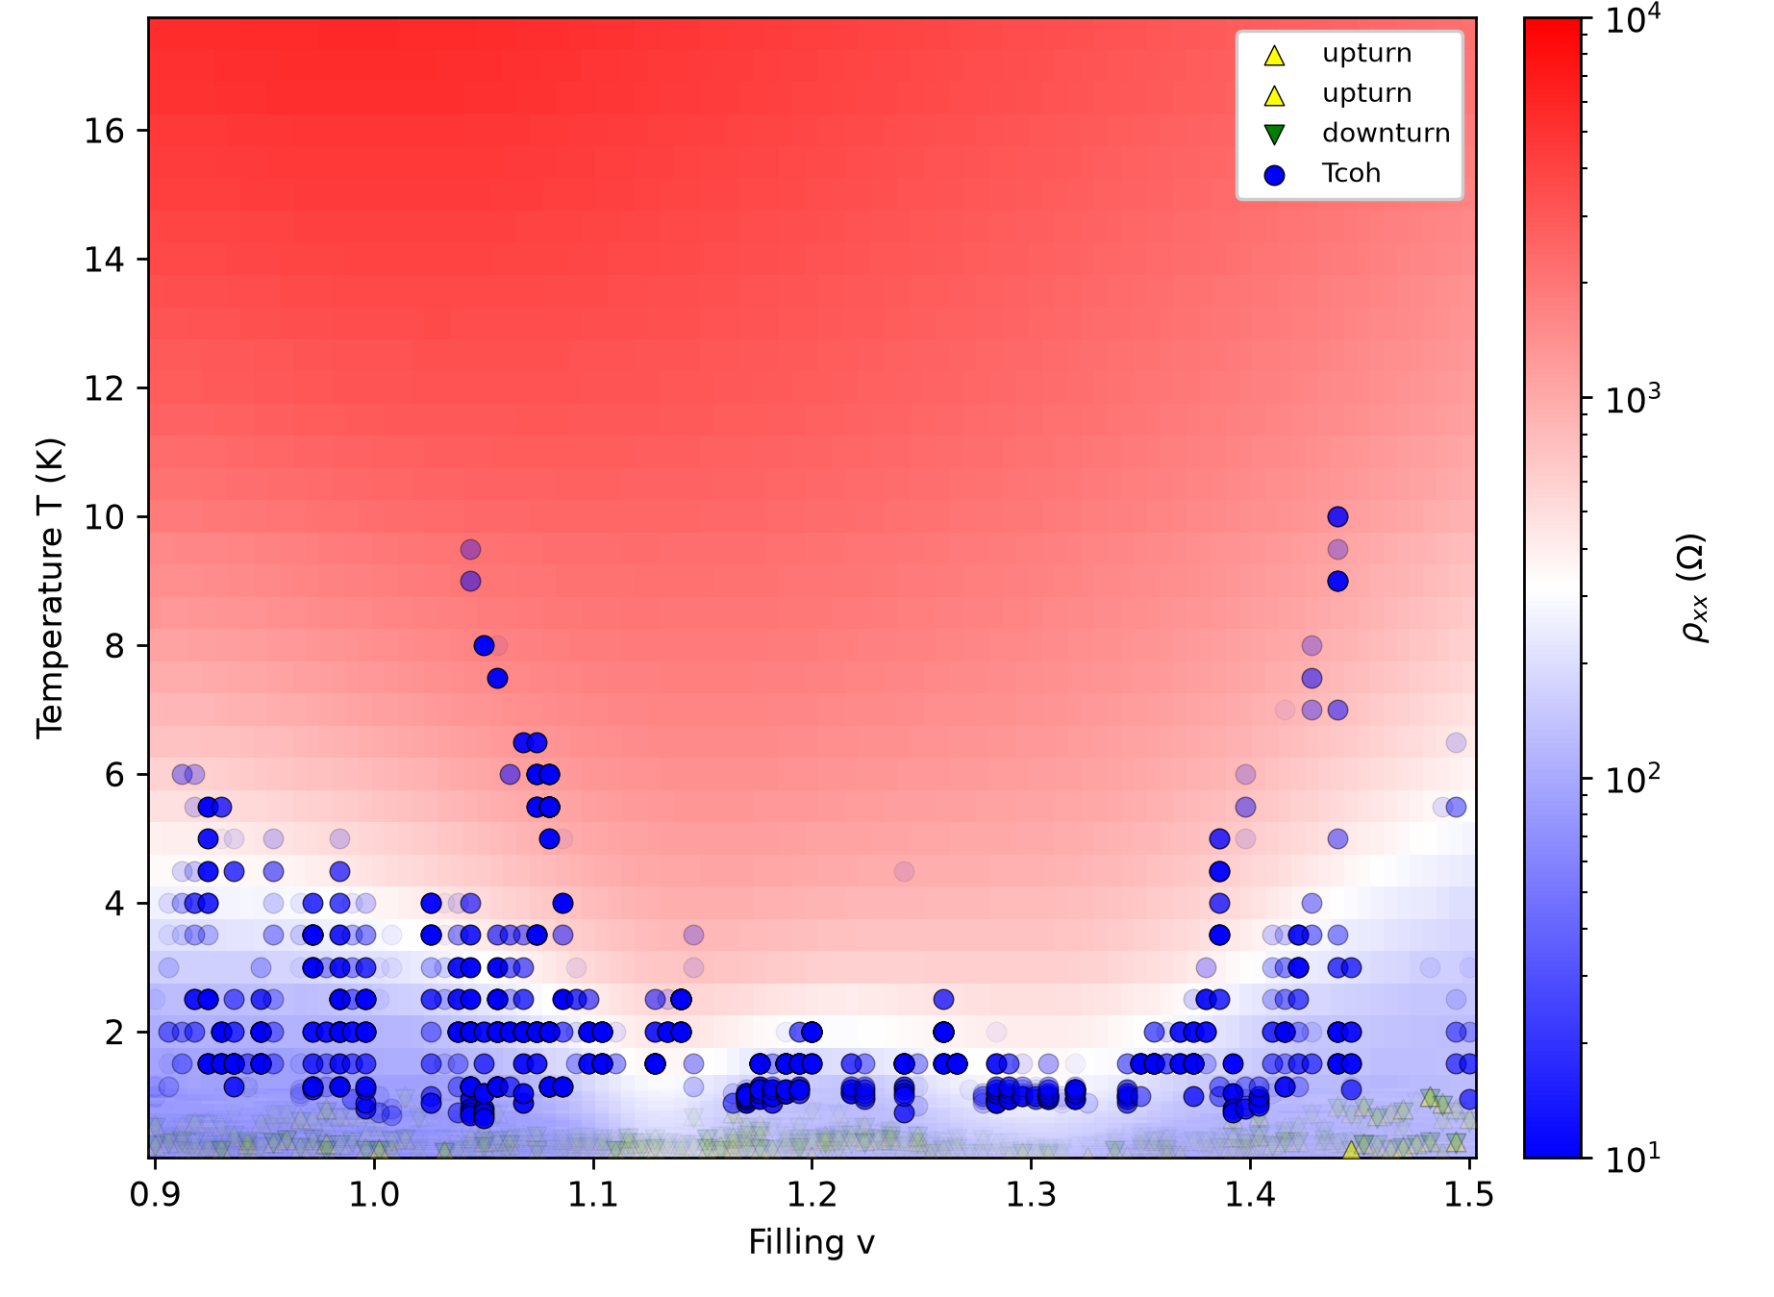
Figure 12. Generated phase diagram for E = -176 mV/nm dataset

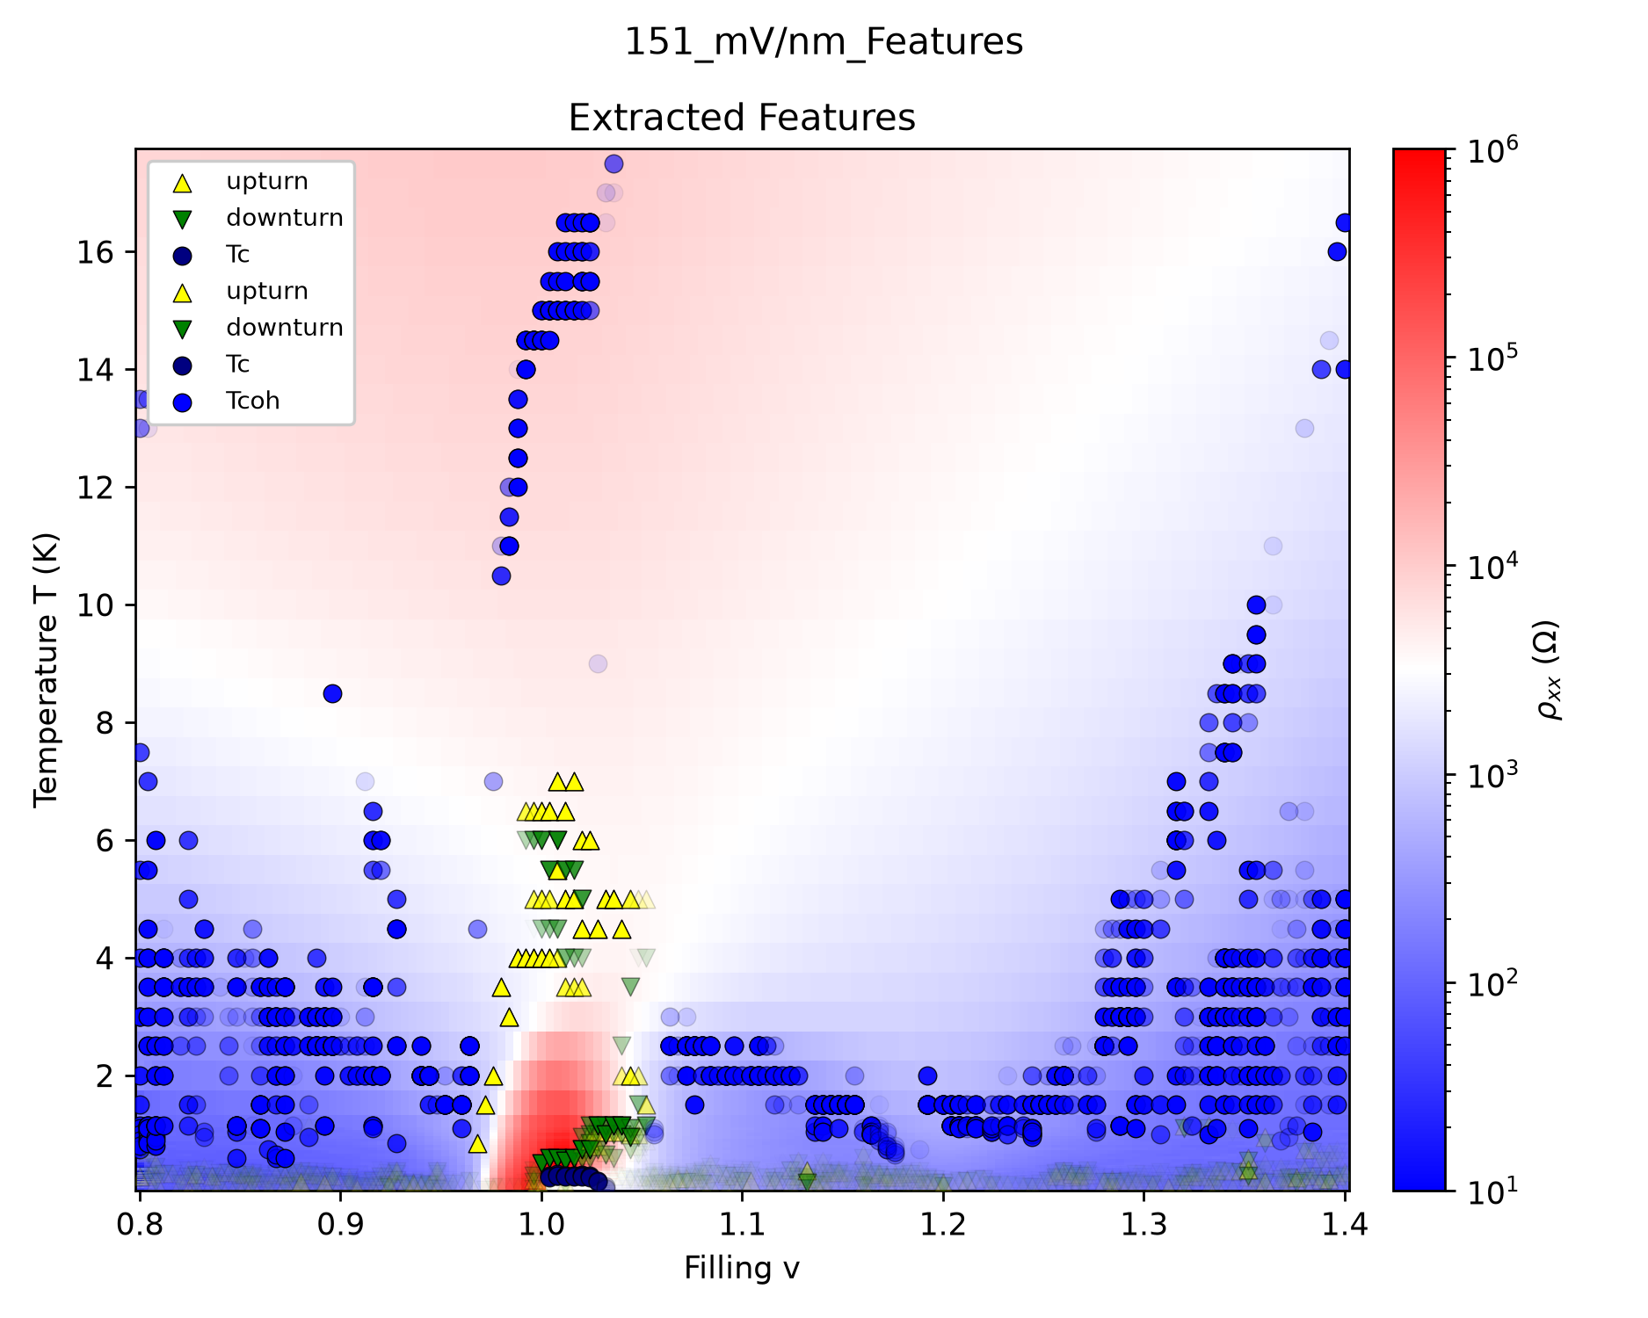
Figure 13. Generated phase diagram for E = -151 mV/nm dataset

Future Directions

Several changes can be made to improve this pipeline. In the immediate future, the extraction of T’ can be implemented using the same logic for T_{coh}. Additionally, rough phase boundaries can be drawn to connect the extracted candidates.

In the near future, a database can be curated for more precise phase labeling - for example, simple rules such as labeling a low temperature region with T² dependency as Fermi liquid. This would allow accurate phase labeling of phase diagrams from the features and behaviors extracted so far.

Ultimately, the end goal for this project would be to package the pipeline into a skill for an agent to use. Since many processes in the pipeline have tunable parameters, for example z-score for smoothing and hill-sigmoid calibration for scoring local extremas, the agent would be able to generate multiple candidate phase diagrams by running the pipeline through multiple parameters, and ask a human expert for feedback and verification. After feedback, the agent readjusts the parameters, and is able to generate more accurate phase diagrams. This would help ensure that the generated phase diagrams are reproducible and physically meaningful while reducing the time required to generate a high-quality phase diagram.

Code Availability
The code developed for this project can be found at the following github repository: https://github.com/w8-what/moire-data

References

[1] Y. Xia, Z. Han, J. Zhu, et al., “Bandwidth-tuned Mott transition and superconductivity in moiré WSe₂,” Nature 650, 585–591 (2026). https://doi.org/10.1038/s41586-025-10049-3

Acknowledgements

I would like to thank my mentors Dr. Xiao Wang and Yiyu Xia for providing guidance and support throughout my research journey, as well as supplying the datasets and original workflow procedures

I would also like to thank my Professor Eun-Ah Kim for her mentorship as well as giving me the opportunity to work on this project.

This material is based on work supported by the AI Research Institutes program supported by the NSF and Intel Corporation under NSF award DMR-2433348

